Dan Patrick Rusak - Resume of Qualifications

merlinlabs@rseincorp.com
www.codeslinger.us\
480-217-3397
http://codeslinger.us

Career Summary:

30 years of experience in Open Source and Real Time Operating System Development, J2EE, Applications Development, Development Tools, Embedded Software (firmware) Development, Systems Installation, Systems Test and Maintenance, Database Design, Dump Analysis, Communications Software Design and Implementation, Software Debug, ISO Software Inspections, Cloud Components Openstack and Jcloud, 3270 terminal interfaceing, Paas , Mainframe, Ecommerce.

Knowledgeable in Cloud Computing, Linux scripting, admin and api, emedded C, java, j2ee, Apache Maven, Apache Ant, Munin performance graphing, eclipse plug-in and rcp development, Junit test, Jsp, Jms, Servlets, cvs/svn/git, log4J, xml processing, gui implementations, Model-Driven Architecture Junit Test,Golang, WebServices, UDDI, Tomcat-based application servers , SQL, PostgreSQL, various High-level languages, Velocity templates and engines, Hudson Builds, Perl, Assembler Languages, Windows API, network communication protocols, large mainframe and small real time software environments and Wordpress.

Professional Experience:

August 2016 to present.

Developing Ecommerce interfaces utilizing Wordpress/Python and Shopify .

October 2016 to August 2016
ATOS

Last primary assignment was development of a 3270 terminal concentrator to manage 10,000 terminals and interface to an HTTP servlet and associated demo and test drivers. This was to engineer an operable solution to a rube-goldberg design by Atos staff. This involved writing user interfaces in Linux C utilizing standard sockets and HTML API. Terminal drivers were written in Java and Golang.to simulate large terminal loads, displaying the loads graphically.
January 2016 to October 2016
ATOS
Developed An Openstack/Jcloud interface to run computer benchmarks (SPECVIRT), a very complex undertaking that was beyond the capabilities of the standard ATOS engineer.

June 1997 to December 2014
Bull Worldwide Information Systems
13430 North Black Canyon Highway
Phoenix, Arizona 85029
Senior Software Engineer

Previous assignments were development and support of an Eclipse RCP User Interface to the Bull Database Appliance as the single point of management of database storage servers and virtual machines, including undockable windows that monitor in realtime and historical plotting utilizing Munin.
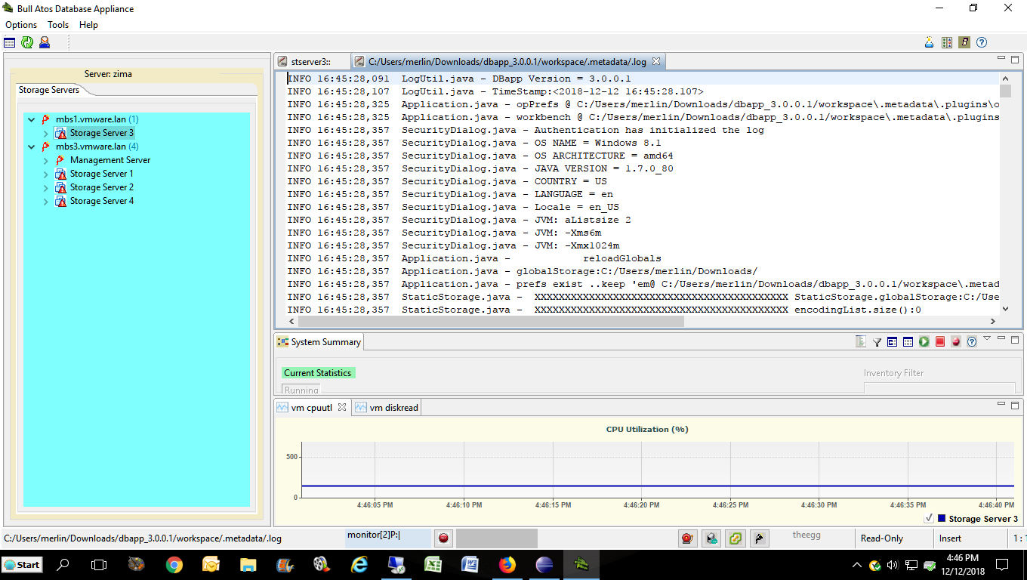 Developed a power-management scheme to assess linux tasks' power consumption from the platform chipsets. This involved linux kernel mods to utilize cpu frequency information from the chipset drivers and IPMI power sensor information and interfacing with the HPC SLURM resource manager. Also processed bug reports on SLURM and submitting patches to LLNL.

Previous assignment is as open-source contributor to Lawrence Livermore
National Labs on behalf of company customers in providing enhancements to SLURM’s
(their High Performance Computing product) graphical user interface, SVIEW, earning high praise from LLNL. This involved utilizing the GTK+ framework and building C code to generate patches to the product for upload to LLNL for review and inclusion in their builds.

Provided Ad-Hoc research papers to Project Management (Puppet, Valgrind, UNITE, Heartbeat,.et.al.) as requested for potential future project integrations.

Previous assignment was project-lead in providing the Dump and Debug solution to Bull High Performance Computing platforms. This involved selecting Open Source Dump and Debug products, wrapping them in customized supe3r user scripts to provide advanced analysis capability for compute node problems across Network Nodes and providing installation packaging and usage documentation. Also provided linux GUI applications to interact with the dump/debug product to facilitate ease of configuration , dump analysis, and obtaining technical support.

Previous assignment was plugin developer (with project leader responsibilities) for a Model-Driven Architecture project (“BSOA”) using an open-source IDE (Eclipse) to facilitate the development and deployment of J2EE Web service applications on Opensource Application Servers (Jonas, Glassfish) from a modeling tool's XML export. The plugins were GUI-based implementations that parse the XML, build a metamodel, then process the metamodel via Velocity engines to generate the Java classes and XML deployment files to complete the Webservice implementations via Spring injection. The services were generated to use Hibernate or EJB3 as the database Connection layer.
Also provided the capability to reverse-engineer a metamodel back into the modeling tool. Wrote Junit tests to support the product.

Previous assignment as project leader on re-design and integration of components of Bull's operating system from the current mainframe environment to an Intel 64-bit PC platform under Linux.
This entailed implementation of shared-memory infrastructures under Windows API
and Linux and socket implementations and the porting of the legacy Unix remote
applications, DSA and IPS, to Windows. Designed the I/O mechanism for the product.
Designed and implemented the shared memory system for the product. Designed and implemented the Buffer Manager for the product. Designed and implemented the Console Manager for the product. Ported operating system components from assembler language (Dispatcher, Fault Handler) into C and C++. Built performance tools in Visual Basic to investigate I/O transfer performance under this system.

Previously, owned primary responsibility for embedded firmware that enables direct
mainframe memory access for data to be passed to a scsi link for file transfer and E-commerce applications, replacing current outdated frontend network processors (codename ‘LCB’).

Other recent assignment was maintenance and support of embedded software ( in C) for Enterprise Connectivity firmware for enhanced peripheral usage and performance utilizing an Intel 960 processor chip. Developed graphical interfaces in MS Visual Basic to process chip diagnostics for ESCON troubleshooting analysis and to support current development of the 64-bit OS.

Dec 1996 to June 1997

Motorola Inc.

8201 N.McDowell Rd.

Scottsdale, Arizona

Senior Software Engineer
Task Leader - MISSI Audit

Responsible for implementation of the Audit Capability of Motorola's Multilevel Information System Security Initiative for the D.O.D. Network Security Manager, a classified information infrastructure composed of trusted software and hardware components. Required U.S. Secret Security Clearance during the project
lifecycle.

June, 1984 to Dec, 1996

Bull Worldwide Information Systems
13430 North Black Canyon Highway
Phoenix, Arizona

Computer Engineer III

Developed numerous elements of the mainframe operating system in native assembler language.

Provided dump analysis on in-house and user-site mainframes including submissions of software fixes. Acted in a consultant capacity to other company engineers in a teaming environment. Advised architectural design personnel on certain aspects of the operating system and provided impact estimates of proposed software design changes. Participated in the initial software validation and software restructuring to support new mainframe
designs as they became available for market. Participated in and held ISO Software Inspections . Project Leader on various development projects.

Assisted in re-porting STK's Cartridge Tape Library software
in C.

Wrote Visual Basic applications to assist in Dump Analysis on the Bull Mainframe and to support contracts with Motorola.
Developed Productivity Tools as needed for myself and other engineers. This involved primarily scripted protocols and C modules that operated under mainframe applications as well as tool programs that interface with Bull's Online Dump Analysis Process .

Education:

University Of Richmond
Richmond, Va.

Bachelor of Science, Mathematics
Numerous in-house and external hardware and software courses.

Personal Data::
Sex: Male
Marital Status: Single

